MTECH Project Report

**INTELLIGENT RENTAL RECOMMENDATION SYSTEM**



TEAM MEMBERS

YONG QUAN ZHI, TOMMY A0195353Y

RITESH munjal A0195304H

GARY Ng Jian ZhE A0195367N

ANI sivaram PORKALANGAD AYYAPPAN A0195404E

SANTHIYAPILLAI RAJEEVAN PAUL A0195399E

SOOREJ Mohanadas Ganga A0195397J

M.TEcH 2019 BATCH

Table of Contents

1. EXECUTIVE SUMMARY 2

2. INTRODUCTION 3

3. PROJECT LIFECYCLE 4

4. KNOWLEDGE MODEL 6

4.1 Knowledge Acquisition 6

4.2 Knowledge Representation 8

5. SYSTEM IMPLEMENTATION 10

5.1. System Architecture 10

5.2. Project Scope 11

5.3. Assumptions 11

5.4. KIE Rules Design Process 12

5.5. System Capabilities 17

5.6. Areas for Improvement 17

6. CONCLUSION 18

7. BIBLIOGRAPHY 19

## EXECUTIVE SUMMARY

The ability to find a dwelling that is well tailored to your needs can be a challenging task to most tourists, students or working expats. With a multitude of websites in the rental industry today ranging from Agoda and Airbnb to PropertyGuru, our Intelligent Rental Recommendation System (IR2S) stands out of the crowd by leveraging on Machine Reasoning Techniques to allow a home seeker pick the best suited property from the several thousands that are available in the market

For a property owner, as the saying goes, you never get a second chance to make a good first impression. When your listing is placed on IR2S, you are going to get the happiest tenant in your history. While getting into rental business required mastery of niche marketing techniques traditionally, now all you need here is to key in your postal code and price. IR2S will add the necessary bells and whistles to your advertisement, bringing your best tenant who is looking for a property out there.

Well, it’s not just the tenant and landlord that benefits from IR2S. In future, we can scale the current application to include the following enhancements. As soon as an ideal match is generated, the most suitable mover companies can be intimated automatically, making your relocation a seamless experience. Other businesses such as travel agents, restaurants, helpers, part-time maid agencies, tuition centers can also subscribe to IR2S knowledge model so they can be well informed about their potential new customers for targeted marketing. Placing such business ads on the IR2S website will generate a revenue model as well.

## INTRODUCTION

Traditionally, most people on holidays would have chosen Expedia, Agoda or Booking.com to find a place to stay. This trend has slowly changed to a unique approach by Airbnb which nurtures a culture of sharing, thereby mutually benefitting both parties. The tenant can get an affordable place of stay when compared to expensive hotels whereas the landlord can make an income by sharing their existing place of stay without any massive investments.

Similarly, a person or a family who is moving for study or work to a place about which they have little knowledge, will mostly leverage on traditional websites such as PropertyGuru or Craigslist. In Singapore, these rental websites display on average around 30,000[1] properties as available. A user then has to skim through these lists that only shows the address of the property, pictures and price. This leaves him/her to decide on their own, when there may be only little knowledge about the locality and other attributes that may have a holistic influence on the living conditions.

In our team of 6 NUS graduate students, majority who are foreigners also faced these problems while relocating to Singapore. We had chosen a property to stay based on the aforementioned traditional websites and later felt it could have been better in several ways if there was a good knowledgebase for a more intelligent decision making. For example, our team mate Ani decided to stay at an affordable place near his office, but after relocation he could not find any childcare nearby causing unnecessary additional travel to a distant facility.

We hypothesize that a fair number of people have not put in sufficient thought into the decision for rentals and come to regret it later. They merely selected the “Best Option” available to their budget. Best in what sense? They may not even be able to describe it. Our intelligent Rental Recommendation System overcomes these problems by selecting the best properties based on important user attributes which we have gathered through several interviews.

## PROJECT LIFECYCLE

The first phase was **PROJECT INITIATION** where all pre-project work was done. This involved our team defining the opportunity, discussions on the merits of project options, and getting the consensus to move forward.



Figure 1: Project Life Cycle

Our team had identified 6 different projects as listed in Table 1, from which we decided to go ahead with IR2S after careful consideration on the factors such as:

1. Implementation of knowledge based reasoning techniques & tools
2. Efficient usage of rule based system, KIE
3. Complexity in implementation
4. Availability of resources
5. Feasibility of implementation within the stipulated timeline

|  |  |  |  |
| --- | --- | --- | --- |
| **No.** | **Title** | **Description** | **Resources** |
| 1 | Movie Recommendation | Recommend new movies based on what user has been viewed | IMDB movie dataset |
| 2 | Health and Fitness Tracker | Maintain, Loose or Gain Weight by calculating Calorie Bank | References uploaded txt file on slack |
| 3 | Match Maker | Find the people of same likes, dislikes |  |
| 4 | Intelligent Finance Planner | Manage your money |  |
| 5 | **Intelligent Rental Recommendation System** | Find the rental apartment based on preferences and weightage | Data.gov.sg, PropertyGuru, Google Maps, Real Estate Agents & Online surveys |
| 6 | Intelligent Tour Planner | Tour recommender based on social media profile | Social Media, Google Maps |

Table 1: Project initiation

In the **PROJECT PLANNING** phase, our team sat down for discussions on requirement analysis.

For the requirement analysis, the key tasks include:

1. Break down all the work that needs to be done into tasks
2. Estimate the time, resources and budget required to complete each task, and
3. Define acceptance criteria

|  |  |  |
| --- | --- | --- |
| **Timeline** | **Deliverables** | **Owner** |
| 02-Mar | Get compatible API's for knowledge acquisition | Gary |
| 02-Mar | Implement Web Crawlers and build database | Paul |
| 02-Mar | Input / Output parameters listing | All |
| 02-Mar | Business Rules | All |
| 02-Mar | Install KIE on AWS | Ritesh |
| 05-Mar | Interviews | Tommy |
| 05-Mar | Algorithm, Business Rules & KIE | Tommy |
| 05-Mar | Frontend design & Development | Tommy |
| 05-Mar | Database Connection | Soorej |
| 08-Mar | Project management & documentation | Ani |
| 08-Mar | Video report | Tommy |
| 09-Mar | Final Submission | All |

Table 2: Requirement Analysis

With the completion of planning phase, our team entered the **PROJECT IMPLEMENTATION** phase, which will be covered in detail in the next sections.

Our group first set out to build a sizeable knowledge base by conducting interviews and online surveys. While building the system, we utilized tools such as Python based Scrapy to scrape data from common rental websites in Singapore. This information was utilized to build datasets, inserted into H2 database for being synthesized by the rule-based engine and model management in KIE. The frontend was developed in Thymeleaf and Springboot, and to add icing on the cake, we deployed the entire application as a website on AWS to allow everyone access easily

## KNOWLEDGE MODEL

Knowledge model is combination of 2 main aspects:

* Knowledge Acquisition
* Knowledge Representation

We have used various techniques for both processes to design the knowledge based ‘Intelligent Rental Recommendation System (IR2S). The details of methods used are mentioned as below:

### 4.1 Knowledge Acquisition

Some of the techniques used for knowledge acquisition for the system requirements are:

* Domain Expert (Real estate agents) Interviews
* Software Company Review
* Online User Survey
* Online Media
* Case studies

| **S.No** | **Information Source** | **Acquisition Technique** | **Information** |
| --- | --- | --- | --- |
| 1 | Property Agents | - Elicitation of tacit knowledge through interviews and mails | - Provided insights on the current market trend  - Basic requirements for a rental apartment from tenant and owner point of view |
| 2 | Software Company Insight | - Elicitation of tacit knowledge through interviews and mails | - Provided with useful comments on the design aspect for a commercially viable solution to be released in market |
| 3 | User Survey | - Online survey from general population | - Reaffirm the requirements of the rental property from tenant point of view |
| 4 | Online Media | - Web scraping to get the latest available rental units listed in public domain  - Google to get attributes of each listed property | It provides basic information on public housing such as:   -Types of available flats  - Characteristics of available flats which include location, price and unit layout  - Eligibility |
| 5 | Case Studies | - In-depth analysis of HDB BTO system | - Design, architecture and business process. |

Table 3:Knowledge Acquisition Sources and Information

Information collected from interviews and surveys is attached with this report as **Appendix A & B.**

### 4.2 Knowledge Representation

Acquired knowledge was further refined to identify the crux of requirements and represented in the form of Inference Diagram. This process is very important as it clearly highlights the goals of the system and can be used directly to start implementation of knowledge-based system.

 Figure 2: Inference Diagram of IR2S

As shown in the Figure 2, main goal of recommendation system can be divided into 3 inferable sub goals which are further divided into sub-parts to get the information from observables (Questions asked from the user). The process is to get all the information from the user as answers of the Observables, infer the requirements by going through the set of **rules** assigned for each observable and defining the conclusion based on the results of the sub-goals.

The **rules** of the system are defined based on the inputs from various surveys, interviews from property agents and intended tenants. Example of some important aspects brought out from the knowledge acquisition process was that people coming for leisure or holiday in Singapore normally stay in the country for short duration (i.e. less than 1 month) and as per the rules from the Singapore Govt., they are not allowed to rent HDB units for short duration. So, only private property or hotels are an option for them.

On top of established regulations, another important aspect was that choice of apartment among the intended tenants is an individual preference and it differs based on personal interests and needs. This leads to uncertainty in defining the exact match for an individual. Hence a combination of multimodal categorical factors is utilized to refine matches and tailor the results to the user. The categorical factors are first determined empirically, with data gathered through the aforementioned surveys and interviews determining the refinement. The system then provides a recommendation by aggregating together the factors together.

For example, for the tenant looking for an apartment with family, it is assumed that the tenant would be looking for an apartment where number of rooms available should be greater than or equal to the number of people in the family. Should there be children, the recommendation would be refined with conditions like having childcare centers and schools in the vicinity.

## SYSTEM IMPLEMENTATION

We have used an MVC Framework for designing a holistic application which is easy to use for anyone looking for recommendation of rental apartment. The system has been designed keeping in mind the main aspects of being **user-friendly** and providing **ideal recommendations** based on user preferences.

### 5.1. System Architecture



Figure 3: System Architecture - IR2S

The application has been designed on the **Thyme leaf** framework which is a light MVC framework and provides an easy to use web based front end to interact with the rules designed in KIE-Drools. It is a modern server-side Java template engine for both web and standalone environments. **Springboot** does the controller part of the application by defining the queries based on answers from the GUI and guided rules in KIE-Drools. The H2 Database contains all the options of the available rental apartments with defined attributes. Spring boot collects all the recommended apartments from the **H2 database** and displays it on the front-end.

#### **Data scraping methodology**

Our input data is from commercial web based rental applications such as PropertyGuru, 99.co, etc. We used a Python based tool called Scrappy to scrap and extract data from individual listing pages from above listed sites. We normalized and consolidated data based on a primary key, which is a combo key made of property name, property location/address and rental value. Sample scrapped data sheet is attached with the project named data.csv for reference.

#### **Cloud Deployment (AWS)**

One of the key benefits of using KIE tool is that it supports multi user access. We leveraged on it and hosted our JBPM server, Spring boot application layer and DB on AWS, so the number of users who can access the application will not be limited. Our application is hosted on below AWS instance.

URL: <http://52.221.199.219:8090/>

### 5.2. Project Scope

The system is mining a dataset available in the database, which is created based on the various attributes an apartment can contain. The aim of the Project is to show how an efficient Reasoning System can **mine** the ideal options from the available dataset based on the **rules** defined in the KIE-Drools Guided Rules set. The system will generate a set of rental listing criteria based on the user’s answers to various questions and our database will be queried based on the search criteria.

### 5.3. Assumptions

Certain assumptions are made in the development process to simplify the process of recommendation wherever it is required.

Assumption 1: Target audience is mainly people looking for renting the apartment. It is not only foreigners working in Singapore can gain benefit from the web-application, but also local Singaporeans can get benefit who are looking for rental apartment in different parts of the city. Example: During the knowledge acquisition process, one of our teammate, Ritesh’s colleague Jiahua (Singaporean) gave his own apartment on rent and moved to other place in the city as he wanted to stay near a well-known primary school so that his kid is eligible to get admission in the school (Based on Govt. policies, one of the main criteria is that preference is given to candidates who reside in l kilometer radius of the school).

Assumption 2: The survey, interviews and online search is from a limited number of people and it serves as a sample of the population. The results are used to design the algorithm using the holistic approach for the whole population.

Assumption 3: Categorical factors are assigned based on the patterns formulated from mining of the knowledge acquisition stage.

Assumption 4: It is assumed that the residential apartment renting rules remain same as stated in <https://www.hdb.gov.sg/cs/infoweb/residential/renting-a-flat/renting-from-the-open-market/regulations-for-renting-out-your-flat>

### 5.4. KIE Rules Design Process

The inference diagram as shown in Figure 2 is an important starting point to develop the system. The observables identified in the inference diagram are used to capture the preferences of the users and assigned as an attribute to the RULE BASED SYSTEM (KIE-Drools).

|  |  |  |  |  |  |  |  |  |  |  |  |  |  |  |  |  |  |  |  |  |  |  |  |  |  |  |  |  |  |  |  |  |  |  |  |  |  |  |  |  |  |  |  |  |  |  |  |  |  |  |  |  |  |  |  |  |  |  |  |  |  |  |  |  |  |  |  |  |  |  |  |  |  |  |  |  |  |  |  |  |  |  |  |  |  |  |  |  |  |  |  |  |  |  |  |
| --- | --- | --- | --- | --- | --- | --- | --- | --- | --- | --- | --- | --- | --- | --- | --- | --- | --- | --- | --- | --- | --- | --- | --- | --- | --- | --- | --- | --- | --- | --- | --- | --- | --- | --- | --- | --- | --- | --- | --- | --- | --- | --- | --- | --- | --- | --- | --- | --- | --- | --- | --- | --- | --- | --- | --- | --- | --- | --- | --- | --- | --- | --- | --- | --- | --- | --- | --- | --- | --- | --- | --- | --- | --- | --- | --- | --- | --- | --- | --- | --- | --- | --- | --- | --- | --- | --- | --- | --- | --- | --- | --- | --- | --- | --- | --- |
| |  |  |  |  |  |  |  |  | | --- | --- | --- | --- | --- | --- | --- | --- | | **SUBGOAL** | **Questions** | **ATTRIBUTE** | **INFERABLE OR OBSERVABLE** | **KIE FIELD TYPE & VALUE** | | | **GUIDED RULE** | | **KIE Data Model: Data Object** | **Front End** | **KIE Data Model: Object Field** | **KIE FORM: User Interface** | **String, Integer, Float, Boolean, Date etc.** | **Value Range** | **Value Unit** |  | | **Finance (F)** | What is your Budget? | Monthly Budget | Observable | Float | 1 - 50,000 | SGD $ | Apartment Rent <= Monthly Budget | | **Location (L)** | What is your purpose of stay? | Work/Study/Leisure | Observable | Integer | NA | NA |  | |  | What is your location of work/study/leisure? | Work/Study/Leisure Location | Observable | Integer | 10000-50000 | NA | Apartment Location in the locality of place of work/study/Leisure | |  | Renting with family? No. of adults and No. of Kids? | Spouse Work Location | Observable | String | NA | NA | If (Adults >1) | |  | Do you cook frequently? | Near Grocery Store | Inferable | String | NA | NA | If (Cook frequently at home) | |  |  | Near Food courts | Inferable | String | NA | NA | If not (cook frequently at home) | |  | Do you drive in Singapore? | Near MRT/Bus Stops | Inferable | String | NA | NA | If not Drive then location near MRT/Bus Stop | | **Facilities (P)** | Staying with family? No. of adults and No. of Kids? | No. of rooms | Inferable | Integer | 1-20 | Nos | Assumption: Min No. of rooms = Total No. of ppl in Family | |  | Do you exerise frequently? | Gym | Inferable | Boolean | True or False | NA | If Yes then Condo with Gym | |  |  |  |  |  |  |  |

Table 4: Attribute Worksheet for IRRS

The Attribute Worksheet defines the data model and introduces the rules which is assigned in the KIE-Drools system. The Questions asked from the user at the front end (Web-UI) are directly linked to the attributes in data model and Guided Rules.

Next, Guided Rules are clearly identified by the Rule Numbers as shown below:

|  |  |  |  |  |  |  |
| --- | --- | --- | --- | --- | --- | --- |
| **Rule No.** | **Condition 1** | **Logical Operand1** | **Condition 2** | **Logical Operand2** | **Condition 3** | **Sub-Goal** |
| **F-1** | Rent <= Monthly Budget |  |  |  |  | Finance = ok |
| **F-2** | Rent > Monthly Budget |  |  |  |  | Finance = not- ok |
| **L-1** | Work Location Postal Code = Apartment Postal Code |  |  |  |  | Location = ok |
| **L-2** | Work Location Postal Code !=Apartment Postal Code |  |  |  |  | Location = not-ok |
| **L-3** | Cook Frequently = True | AND | Apartment near Grocery Store |  |  | Location = ok |
| **L-4** | Cook Frequently = False | AND | Apartment near Food Court |  |  | Location = ok |
| **L-5** | Drive = False | AND | Apartment near MRT/Bus Stop |  |  | Location = ok |
| **P-1** | Renting with family = Yes | AND | No. of ppl= No. of available rooms |  |  | Facilities = ok |
| **P-2** | Exercise = True | AND | Gym available |  |  | Facilities = not-ok |
| **P-3** | Purpose of Stay = Work/Study |  |  |  |  | Facilities Type = All |
| **P-4** | Purpose of Stay = Leisure |  |  |  |  | Facilities Type = not (HDB) |
| **R1** | F-1 | AND | L-1, L-3, L-4, L-5 | AND | P-1 to P-4 | Final Recommendation List |

Table 5: Guided Rules and Decision Table for IR2S

The identified rules are further represented in the form of Dependency Diagram as shown below:



Figure 4: Dependency Diagram of IR2S Rules

From the above consolidated information, Business Process Model was derived and the resultant flow chart is shown in Figure 5. How the business logic is integrated with the business rules together with categorical factors is also included within the flow chart.

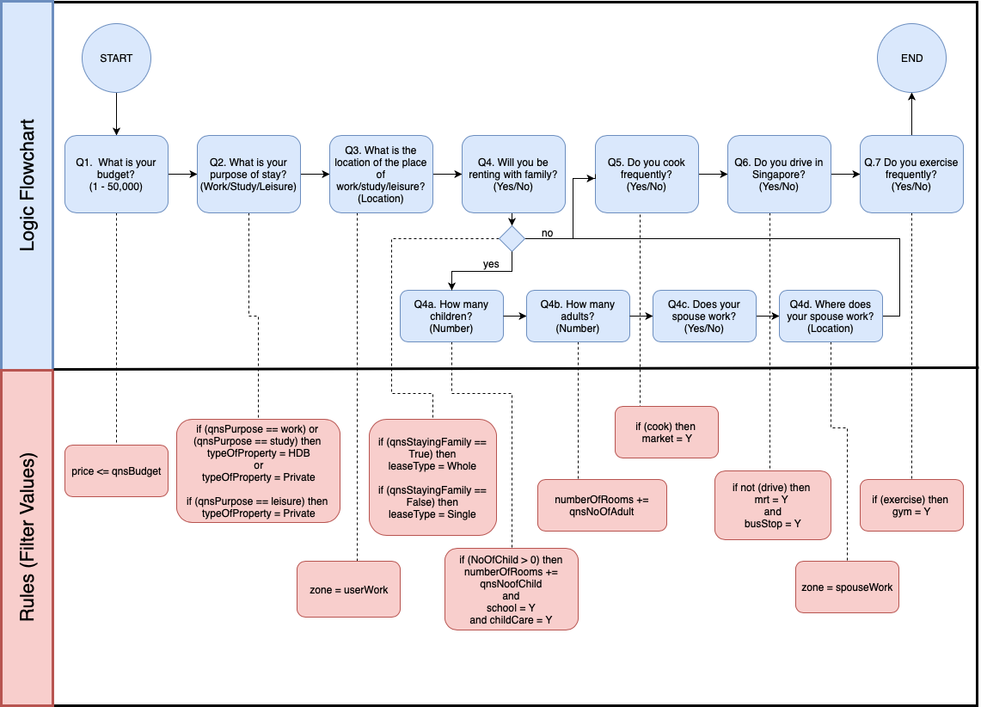

Figure 5: Business Process Model

Based on the knowledge discovered with our interviews and surveys, we generated a list of business rule tasks that caters to each category of knowledge pattern. For instance, we noticed a pattern that people whose work/study location is in the north zone of Singapore, they will generally search for a place to rent in the same zone. Another example, when a person will not be driving in Singapore, they will definitely opt for an MRT or Bus Stop near the rental listing. We took this knowledge and constructed a process flow that will sequentially check for each category in order to assess the ideal types of rental listing to query for the user.

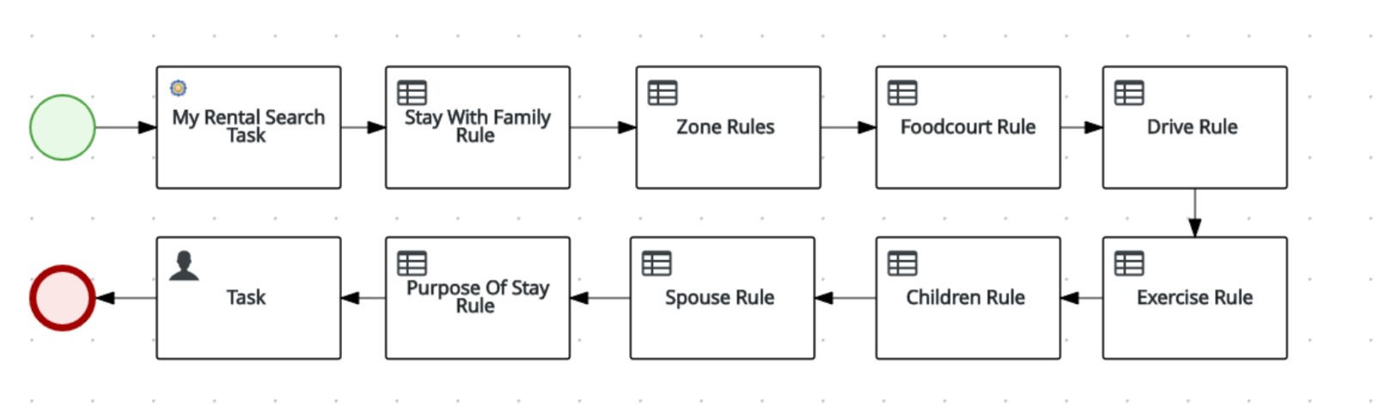

Figure 6: KIE Business Process Diagram

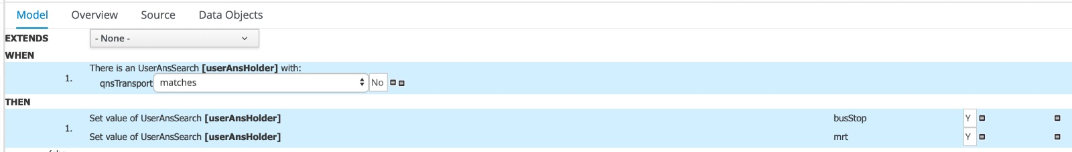

Figure 7: KIE Guided Rules Example

### 5.5. System Capabilities

Starting with **Knowledge Acquisition**, where we obtain data from various sources, churning the data using different **Knowledge Models** to find useful information from the data and defined rules, and then **Mining Data** from the available resources the system intelligently gives the ideal recommendations. Real capability of the system can be verified from the results of the test cases as presented in Appendix D.

As the system is designed as a web application, it is straight forward to access the application through the User Interface. The details of installation of the application are mentioned in the User Manual. The UI is designed on Thymeleaf, a modern server-side Java template engine for both web and standalone environments.

Based on interview with Jeffrey, CEO of [WebApp Wizards LLP](http://webappwizards.com/) Singapore, this system could be a very good commercial solution for the rental property market once it is scaled up with real-time data and clubbed with other features like advertisements and revenue generation packages.

### 5.6. Areas for Improvement

Finding an ideal apartment for living depends on huge number of factors and they may wary from person to person. We considered our solution based on the attributes which are most important to the users based on knowledge acquisition but it could be enhanced by having more sample points. During the development process, it was realized that there is an opportunity to improve the core of our solution by adding features like prioritization of the answers from the user. This could certainly provide more comprehensive results.

## CONCLUSION

The project is a very good example of Intelligent Reasoning System as it incorporates all the important aspects of the Machine Reasoning Systems.

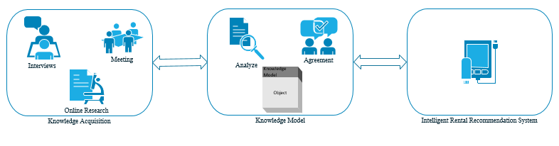

Figure 8: IR2S Project Design Cycle

We started with few ideas in our mind and during brainstorming, the ‘Intelligent Rental Recommendation System’ was selected as the project to work on considering the **business value** and the **value addition** it provides compared to current available solutions in the market.

Through this project, we demonstrated how information gained from other sources can be effectively used to design reasoning systems by data mining and defined rules. Also, we used modern web interface techniques to display output in user-friendly manner. With the application hosted on AWS, it can reach to more users.

## BIBLIOGRAPHY

<https://www.hdb.gov.sg/cs/infoweb/residential/renting-a-flat/renting-from-the-open-market/regulations-for-renting-out-your-flat>

https://www.propertyguru.com.sg/

**APPENDIX A**

**Interview with real estate agent 1:**

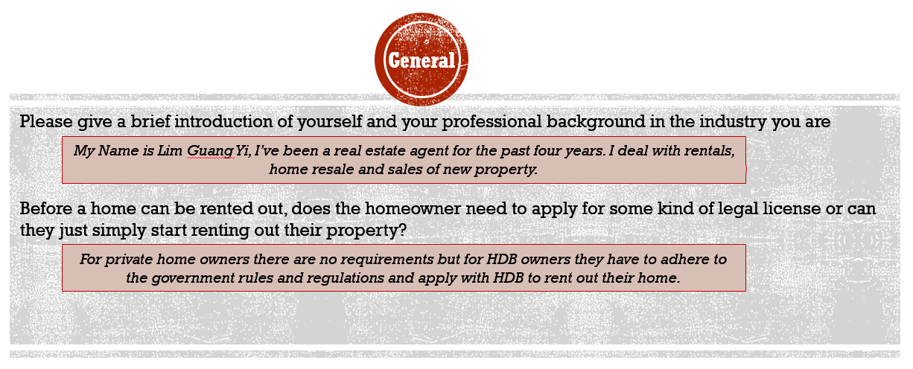

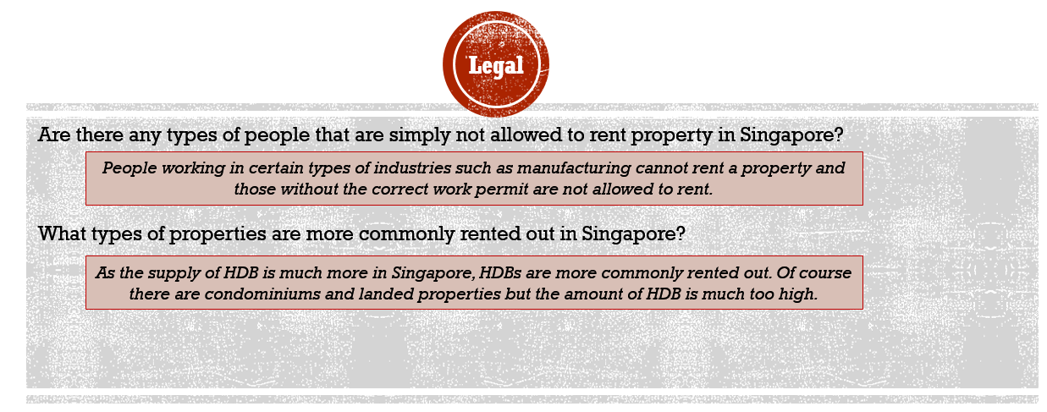

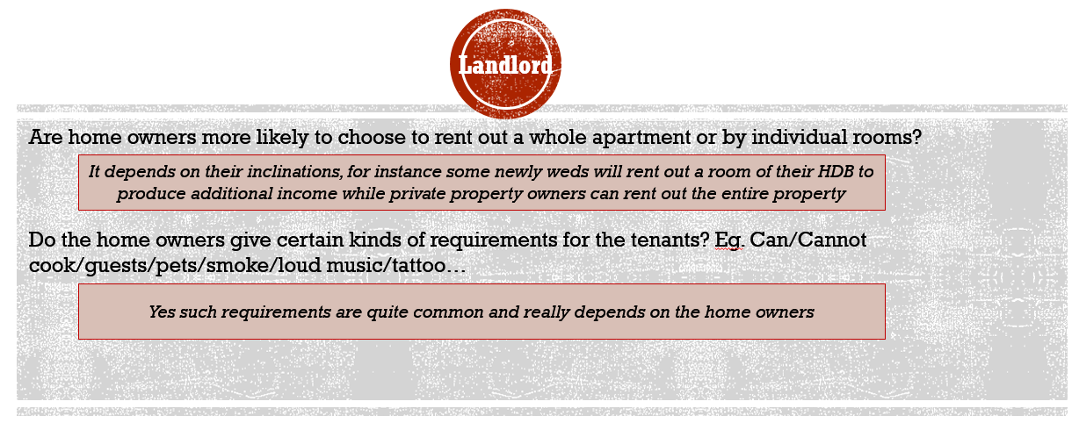

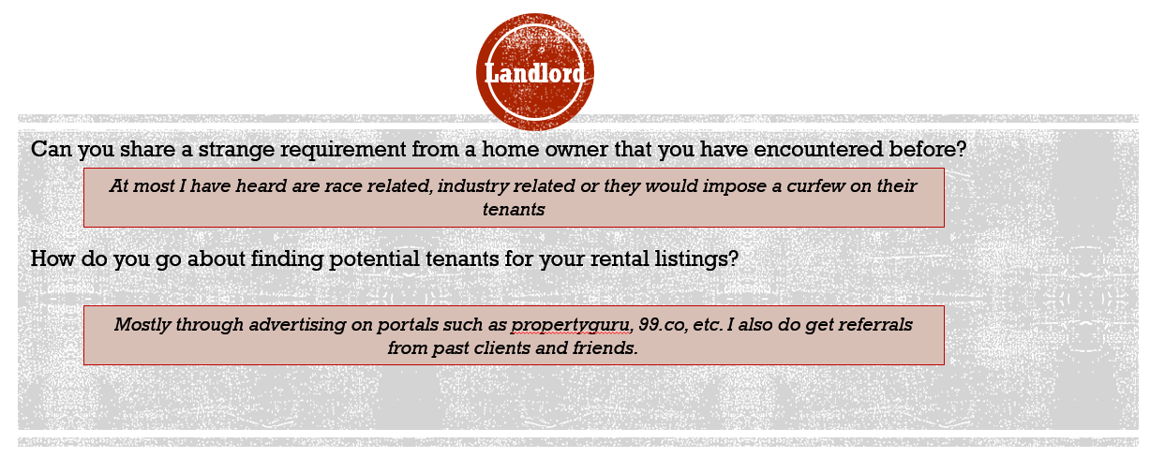

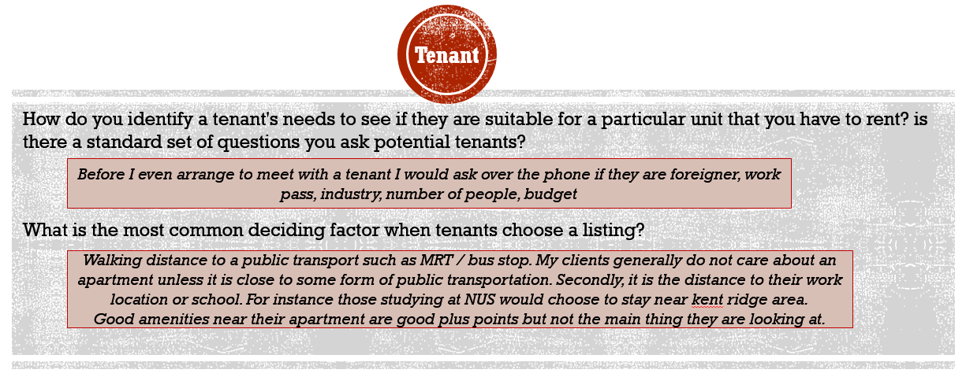

**Interview with real estate agent 2:**

|  |  |
| --- | --- |
| Question | Answer |
| Personal Details | |
| Please give a brief introduction of yourself and your professional background in the industry you are in. | I am TJ and it is my second year into the real estate industry. When I was younger, I followed my mother (a retired realtor now) around for her appointments and having witnessed the hardship and dedication that she displayed during her tenure and the amount of joy and job satisfaction she received whenever a client shows their gratitude to her gave me the motivation to follow her footsteps. |
| Legal Requirements | |
| Before a home can be rented out, does the homeowner need to apply for some kind of legal license or can they just simply start renting out their property? | HDB: Only Singapore Citizens are allowed to rent out their HDBs after fulfilling 5year MOP. SPRs HDB owners are not allowed to lease out. Private (regulated by URA): can start to rent out but may require mortgagee's approval (subjective). Occupancy cap and minimum/maximum rental duration must be met, HDB/URA have different requirements. |
| Are there any types of people that are simply not allowed to rent property in Singapore? | HDB: Non-Citizen Quota have to be met if tenant renting is a non-Malaysian non-citizen (Singapore Permanent Resident or foreigner), respective pass holders (EP/DP/SPASS/WP/SP) must meet the 6mths validity period. WP holders from construction/marine/process industries must be Malaysians. |
| Home Owners related | |
| What types of properties are more commonly rented out in Singapore? | HDB, Condominium, Landed houses – targeted at various group of foreign talent. |
| Are home owners more likely to choose to rent out a whole apartment or by individual rooms? | Active investors will do room rentals as it commands a higher yield, conservative investors will rent out whole apartment. |
| Tenant related | |
| How do you go about finding potential tenants for your rental listings? | Digital marketing platforms (propertyguru, 99.co etc) – these are channels tenants will come to us.  But for us to target a particular group of tenants, schools, offices (where listing is situated in proximity, eg changi biz hub), and ringing up residents from the same precinct are effective. |
| How do you identify a tenant's needs to see if they are suitable for a particular unit that you have to rent? | Key needs are usually no. of rooms, amenities and connectivity. |
| What is the most common deciding factor when tenants choose a listing? | PRICE! being in Singapore where cost of living is higher, price is a huge factor for tenants (unless company is paying) |

**APPENDIX B – Online survey results**

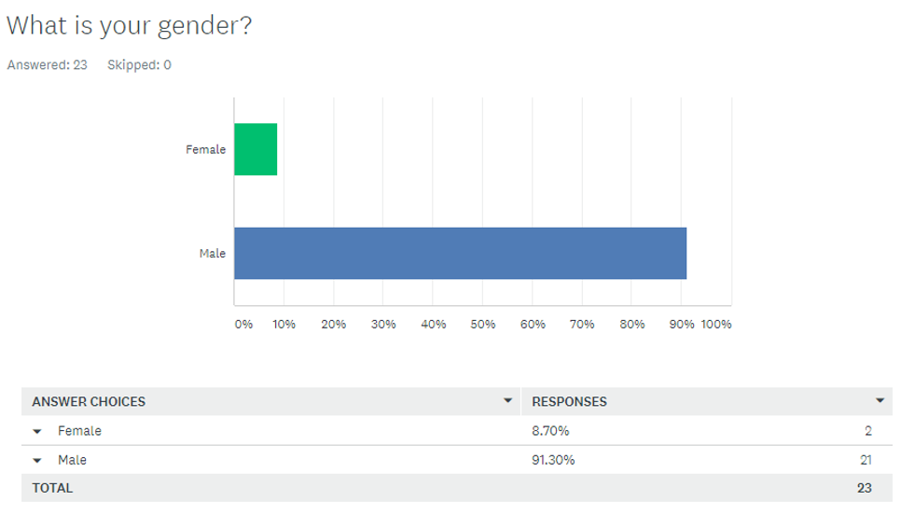

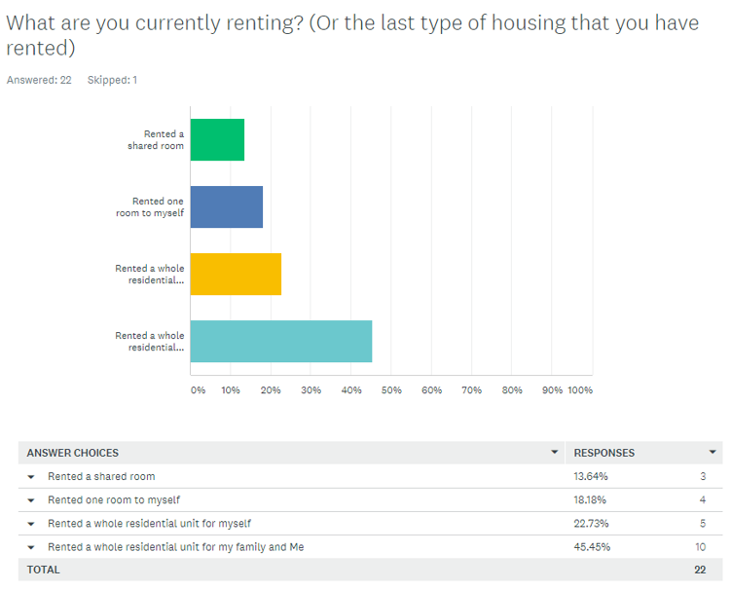

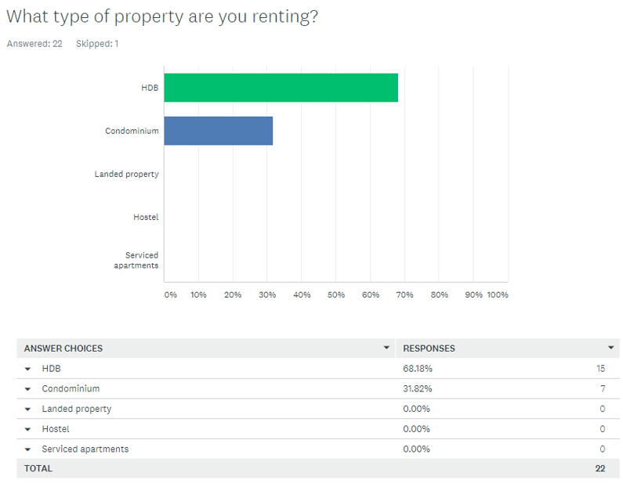

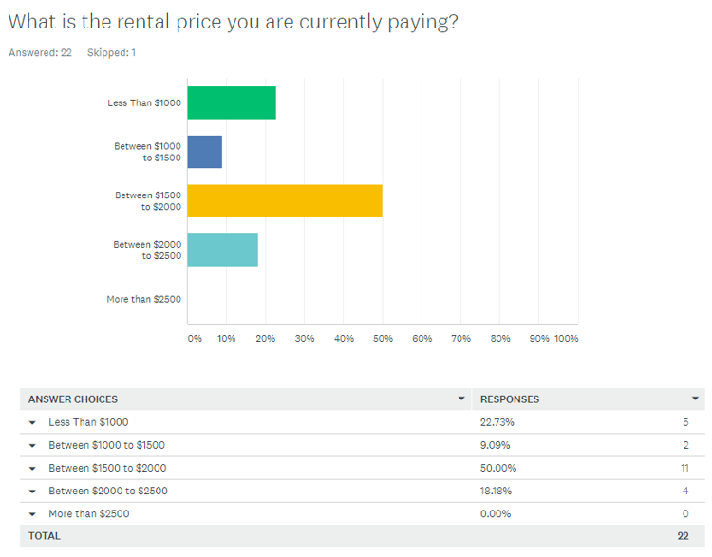

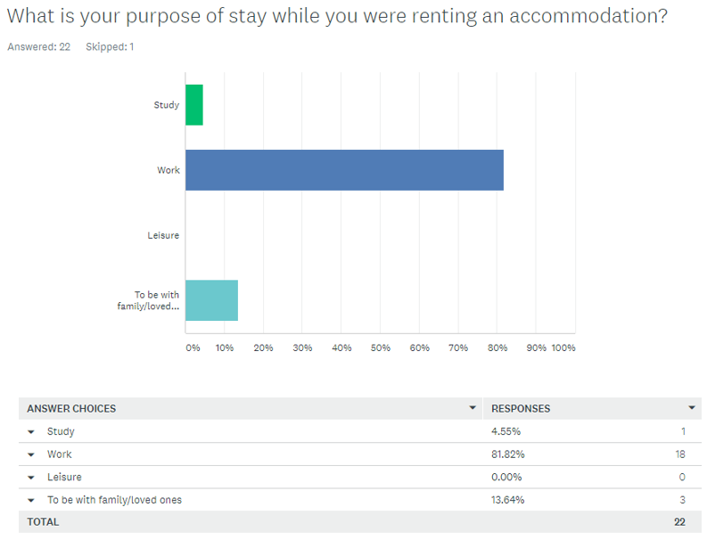

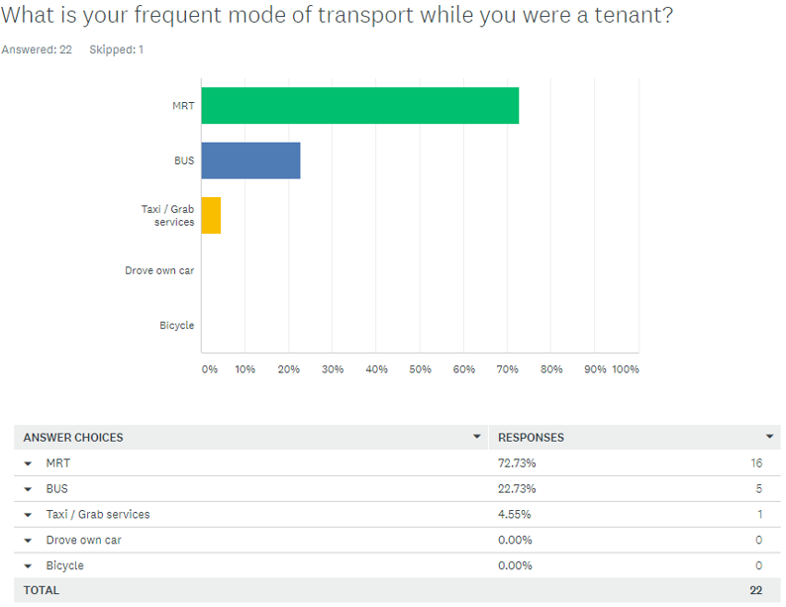

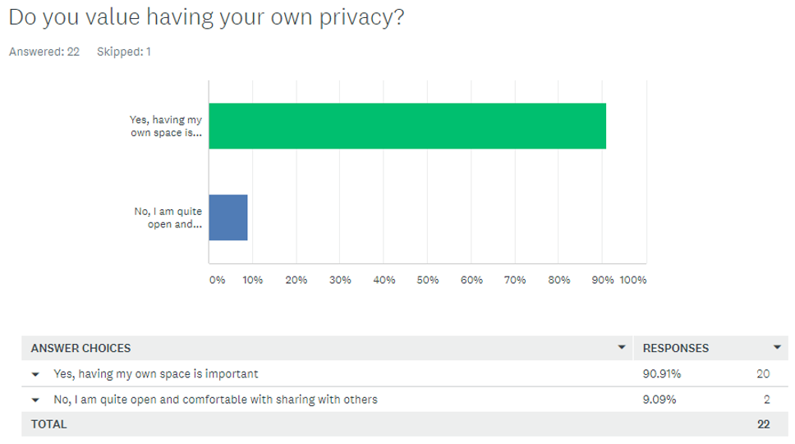

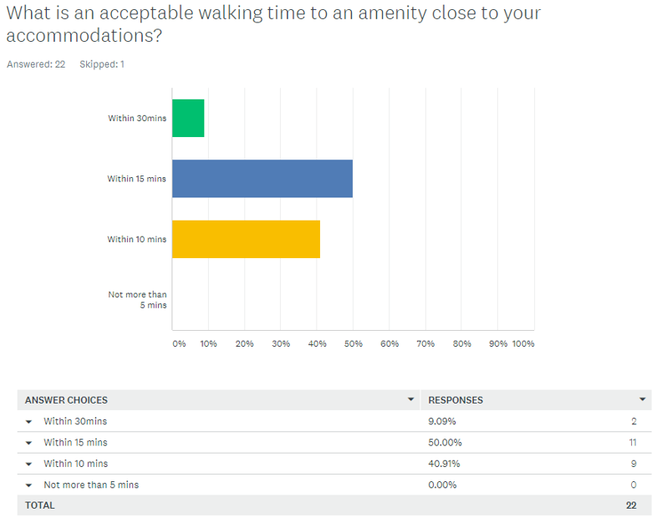

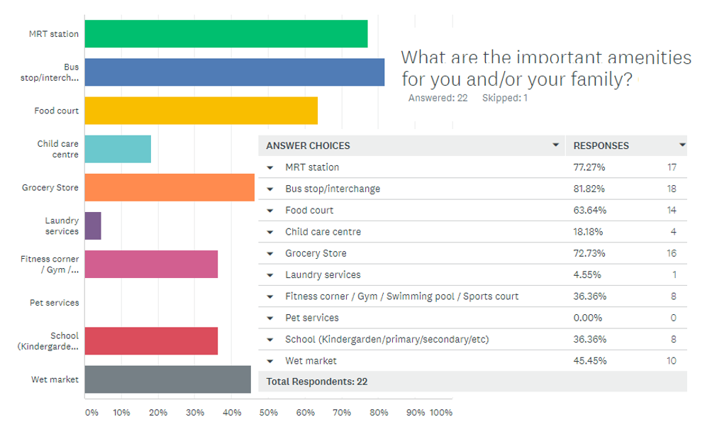

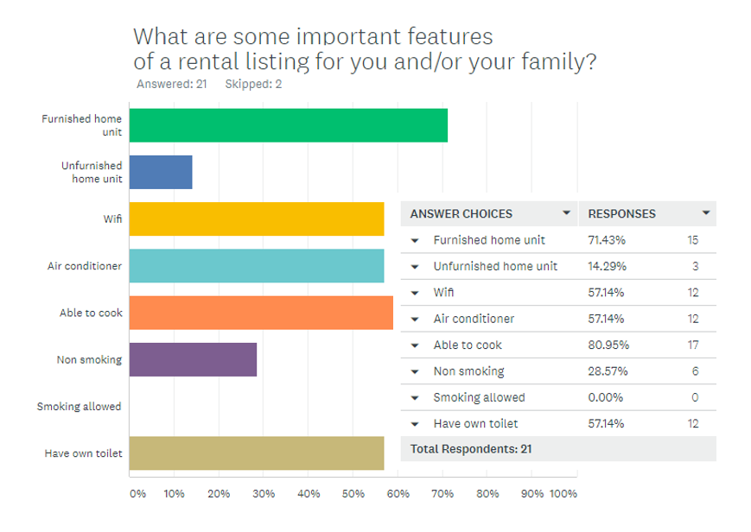

**APPENDIX C – Test Cases**

**Test Case 1**

This test case follows the path of a student that is studying at Nanyang Polytechnic and is looking for a place to rent.

|  |  |
| --- | --- |
| Input | Q1: What is your budget?  Input: 700  Q2: What is your purpose of stay?  Input: Study  Q3: What is the location of your place of study/work/leisure?  Input: 569830  Q4: Will you be renting with family?  Input: No  Q5: Do you cook frequently  Input: No  Q6: Will you be driving in Singapore?  Input: No  Q7: Do you exercise frequently?  Input: No |
| Output | Address: Yishun Central  Price: 500  Furnished: Y  Lease Type: Single room  Mrt & Bustop: Y  Food Court: Y |
| Analysis | Based on the results, the system has recommended this listing for our NYP student as it is within the budget and located in the north zone which is close to where the student is studying.  As the user is a student, he would need a home that is furnished and ready to move in. At the same time, given that he is renting alone, a listing that is only leasing single rooms is taken into consideration.  As the user does not cook much the listing will need a foodcourt nearby. |
| Screenshot of results | (See Below) |

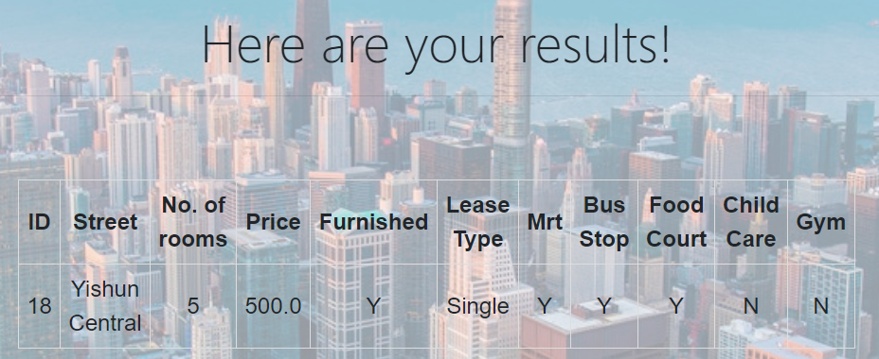

**Test Case 2**

This test case follows the path of a white collar employee who is moving in with his family (wife and 2 children) and working at Apple.

|  |  |
| --- | --- |
| Input | Q1: What is your budget?  Input: 3000  Q2: What is your purpose of stay?  Input: Work  Q3: What is the location of your place of study/work/leisure?  Input: 569086  Q4: Will you be renting with family?  Input: Yes  Q4a: How many children?  Input: 2  Q4b: How many adults?  Input: 2  Q4c: Is your spouse working?  Input: No  Q5: Do you cook frequently  Input: Yes  Q6: Will you be driving in Singapore?  Input: No  Q7: Do you exercise frequently?  Input: No |
| Output | Address: Canberra Street  Price: 2500  Furnished: Y  Lease Type: Whole  Mrt & Bustop: Y  Child Care: N  Address: Sembawang Close  Price: 2700  Furnished: Y  Lease Type: Whole  Mrt & Bustop: Y  Child Care: N |
| Analysis | Based on the results, the system has recommended these 2 listings to our user with a wife and 2 children.  The rental listing has to be for the whole apartment and not just single rooms.  As the user is not driving, it has to be near bus stops and mrt.  It does not need to have child care as the spouse is a stay at home mom. |
| Screenshot of results | (See Below) |

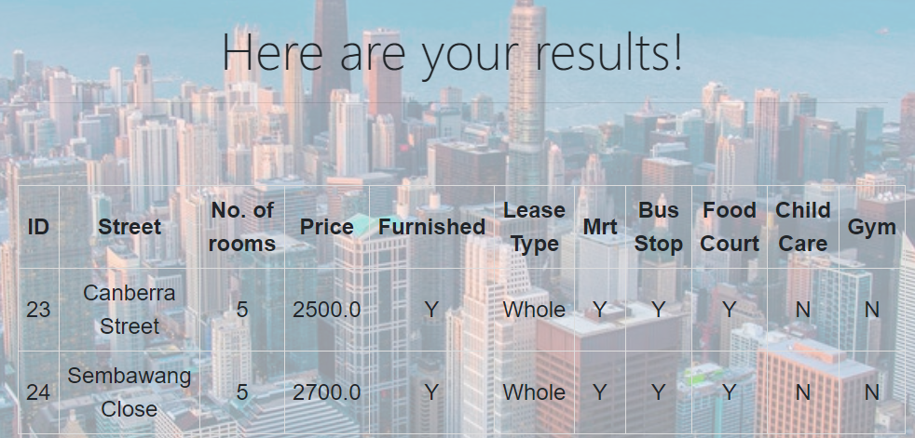

1. Reference to the open public listings on http://www.propertyguru.com.sg